CTLE_gm/id

2020.04.18

1. **CTLE specification**

- Process: GPDK090

- Loading capacitance: 50fF

- VDD = 1.2V

- AC gain: 2 (6dB)

- DC gain: 1 (0dB)

- zero frequency: 1GHz

- bandwidth: 15GHz

- differential input range: 300mVPP (600mVDPP)

- common input and output range: 약 700mV정도로 시작해서 자유롭게 조정

- 테스트벤치: DC-OP 시뮬레이션, DC 시뮬레이션(VTC), AC 시뮬레이션(Frequency response)

1. **설계방식**

: V*=Vin*Adc/Aac*1.414=212mV, gm/ID=9.5~10로 먼저 정하고

-> gain을 만족하도록 저항값들을 정하고

-> bandwidth를 맞추기

parasitic effect가 너무 크다면 gm/ID를 살짝 내리는(=V*를 올리는) 식으로 조정하는 방향으로 설계

1. **gm/ID=9.5~10가 성립하는 nmos width 찾기**

diff pair: finger width=0.62u, Fingers=1, Total width=0.62u

current source: finger width=460n, Fingers=1, Total width=460n

* gm=413.51u, id=42.83u, gm/id=9.65

1. **gain을 만족하는 저항 값 찾기**

: Rs=17k ohms

: RL=10k ohms

: Cs=500f

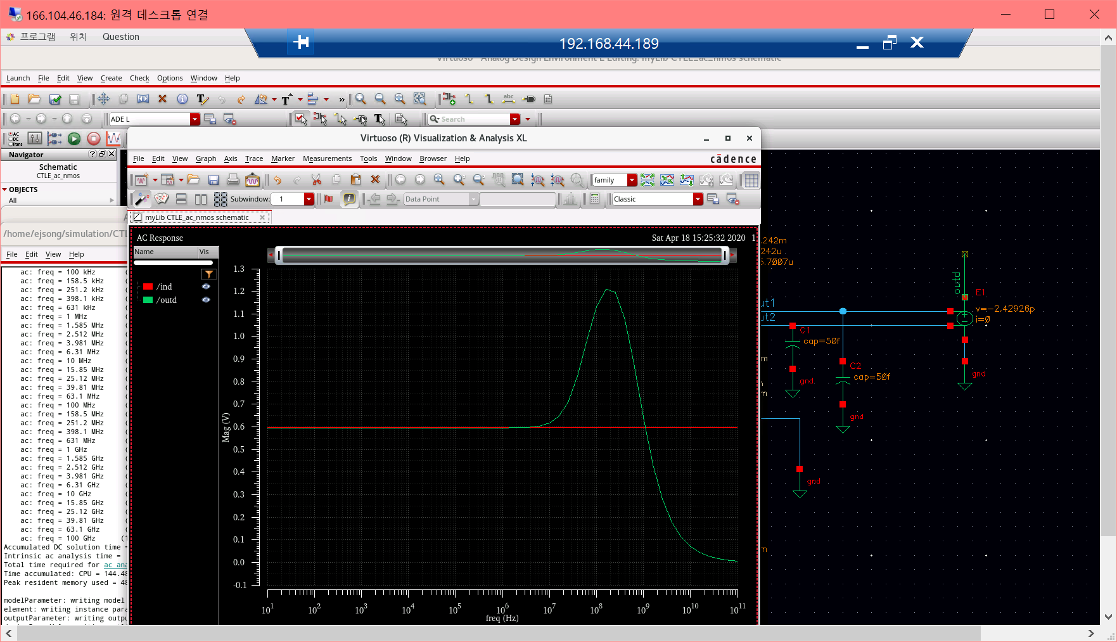

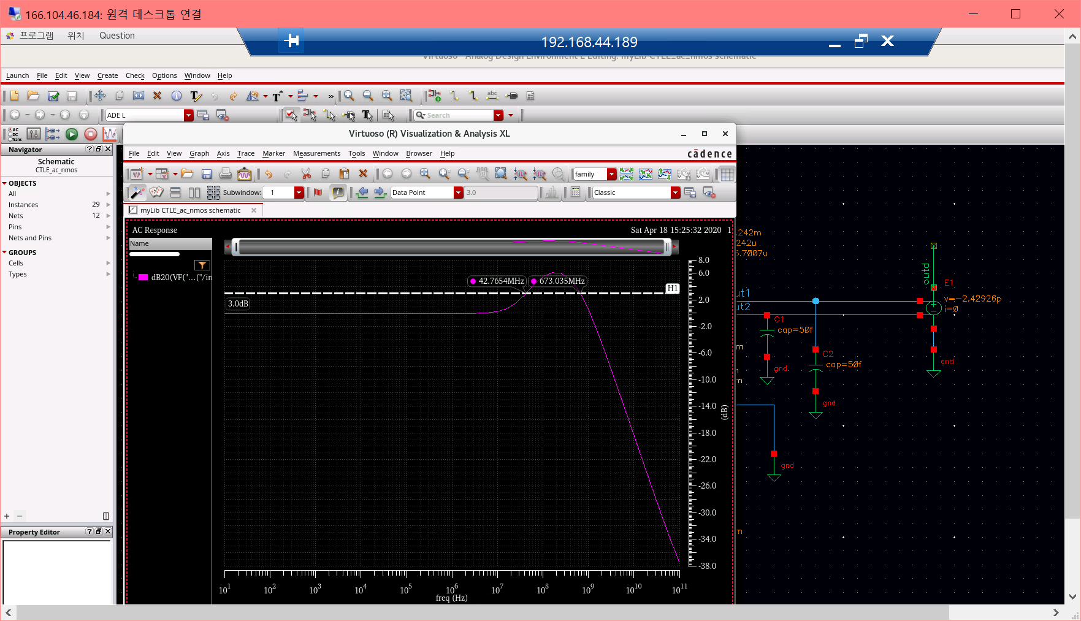

* AC gain=2.017 DC gain=0.995
* Zero frequency=42.765MHz, BW=673MHz

1. **BW 맞추기 위하여 세부 조정**
   1. **Fingers=10, 저항은 1/10배**

: diff pair-> finger width=0.62u, Fingers=10, Total width=6.2u

: current source nmos-> finger width=460n fingers=10 total width=4.6u

: Rs=1.7k ohms

: RL=1k ohms

: Cs=500f

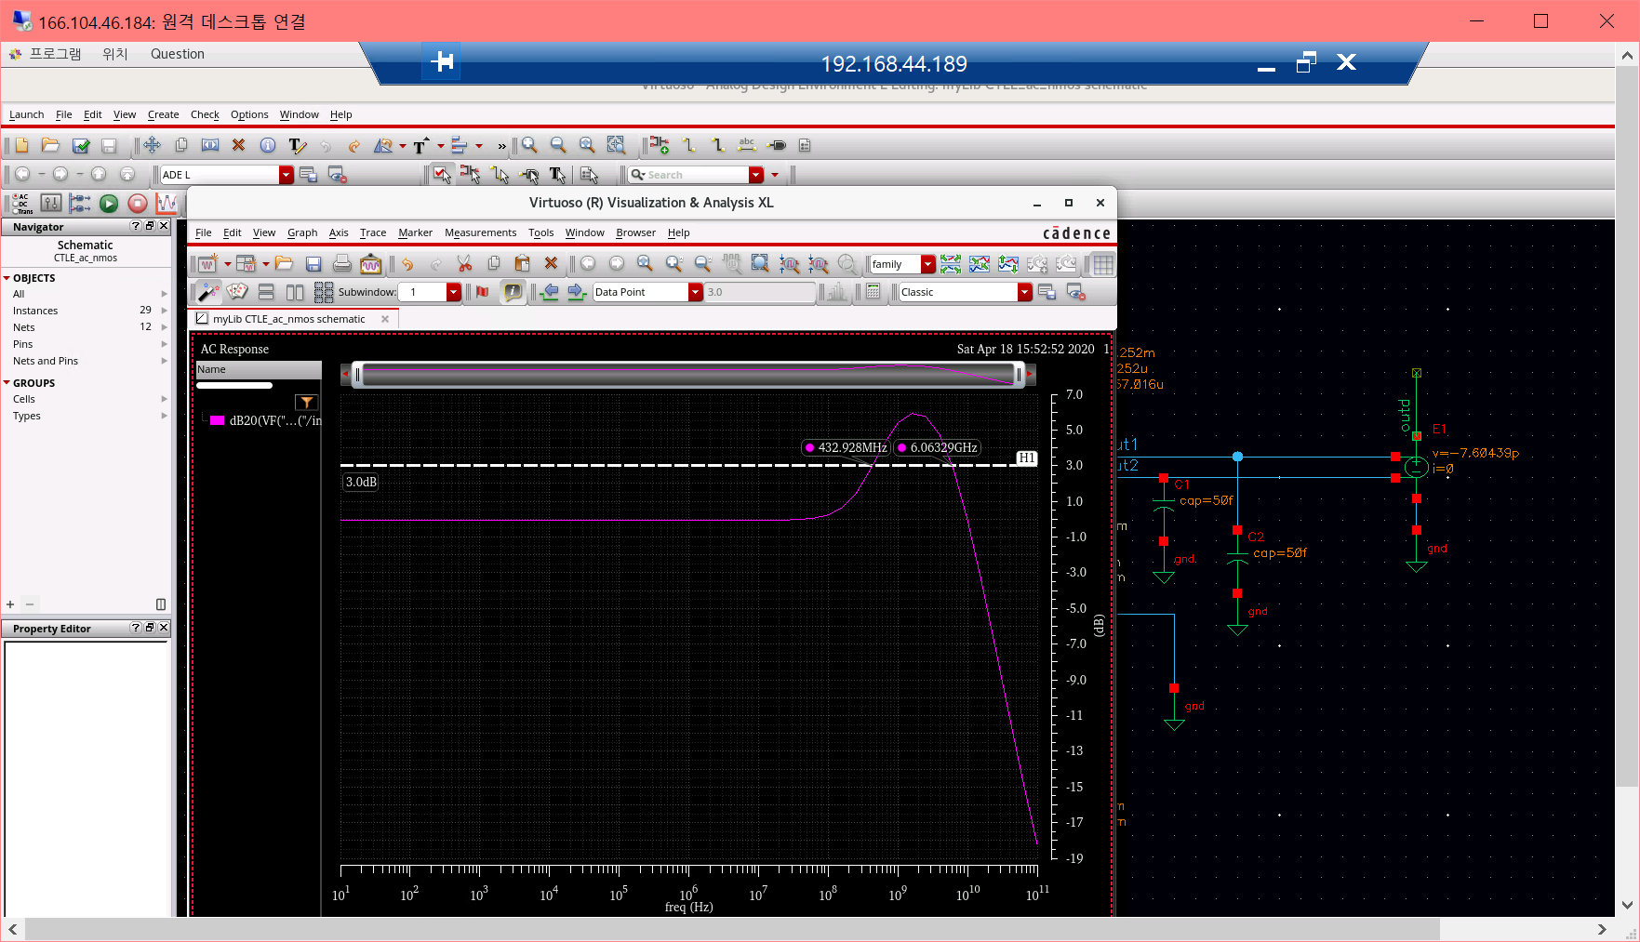

* AC gain=1.62 DC gain=1.05
* Zero frequency=1.27G, BW=6.41G
  1. **Fingers=15, 저항은 1/15배**

: diff pair-> finger width=0.62u, Fingers=15, Total width=9.3u

: current source nmos-> finger width=460n fingers=15, total width=6.9u

: Rs=1.133k ohms

: RL=667 ohms

: Cs=500f

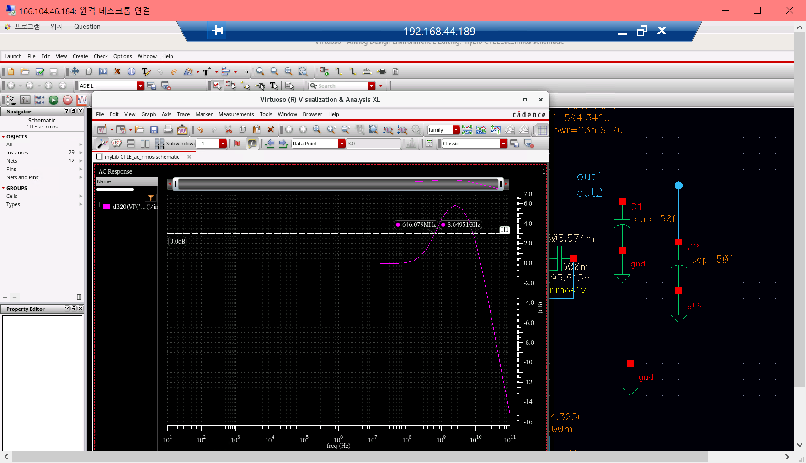

* AC gain=1.963 DC gain=0.995
* Zero frequency=646M, BW=8.65G
  1. **Fingers=20, 저항은 1/20배**

: diff pair-> finger width=0.62u, Fingers=20, Total width=12.4u

: current source nmos-> finger width=460n fingers=20 total width=9.2u

: Rs=850 ohms

: RL=500 ohms

: Cs=500f

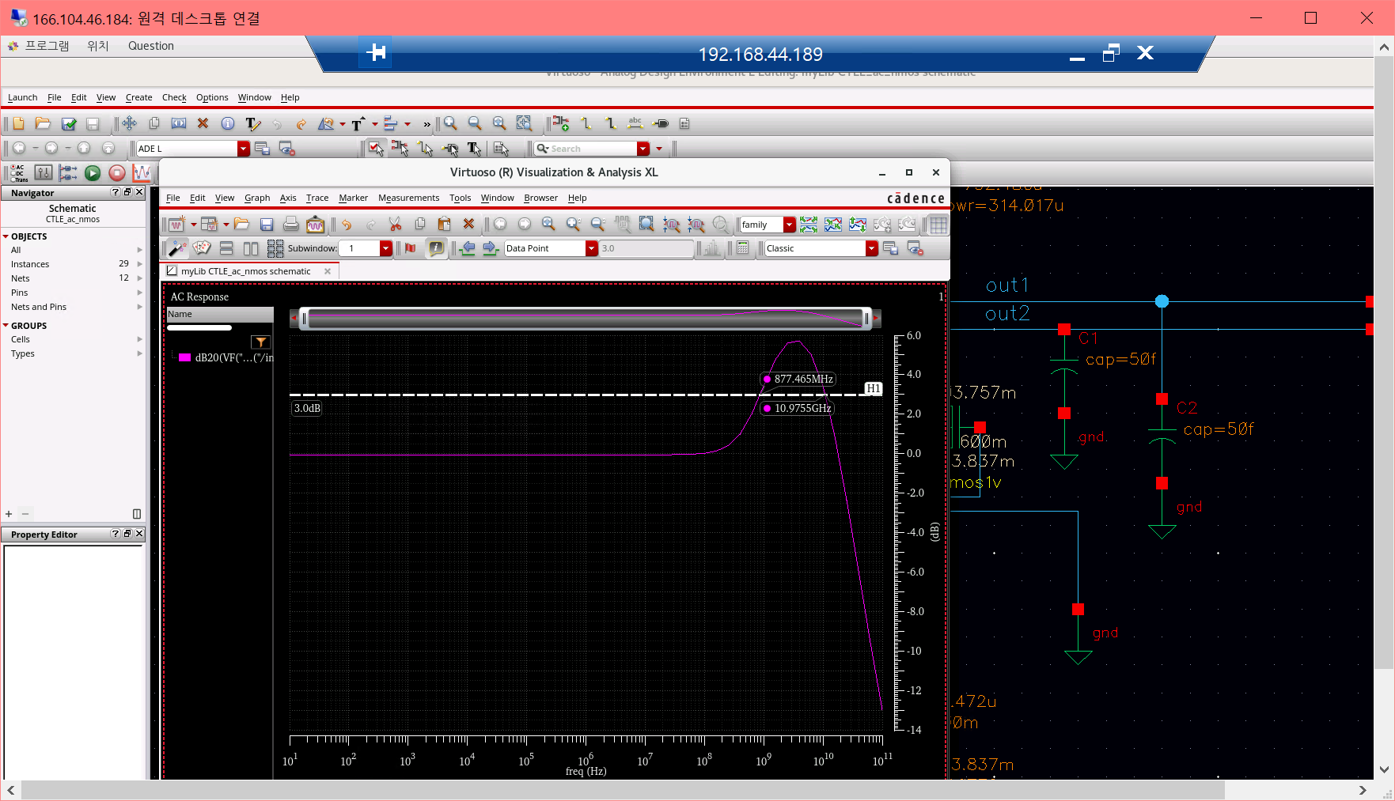

* AC gain=1.92 DC gain=0.993
* Zero frequency=877M, BW=10.98G
  1. **Fingers=30, 저항은 1/30배**

: diff pair-> finger width=0.62u, Fingers=30, Total width=18.6u

: current source nmos-> finger width=460n fingers=30 total width=13.8u

: Rs=567 ohms

: RL=333 ohms

: Cs=500f

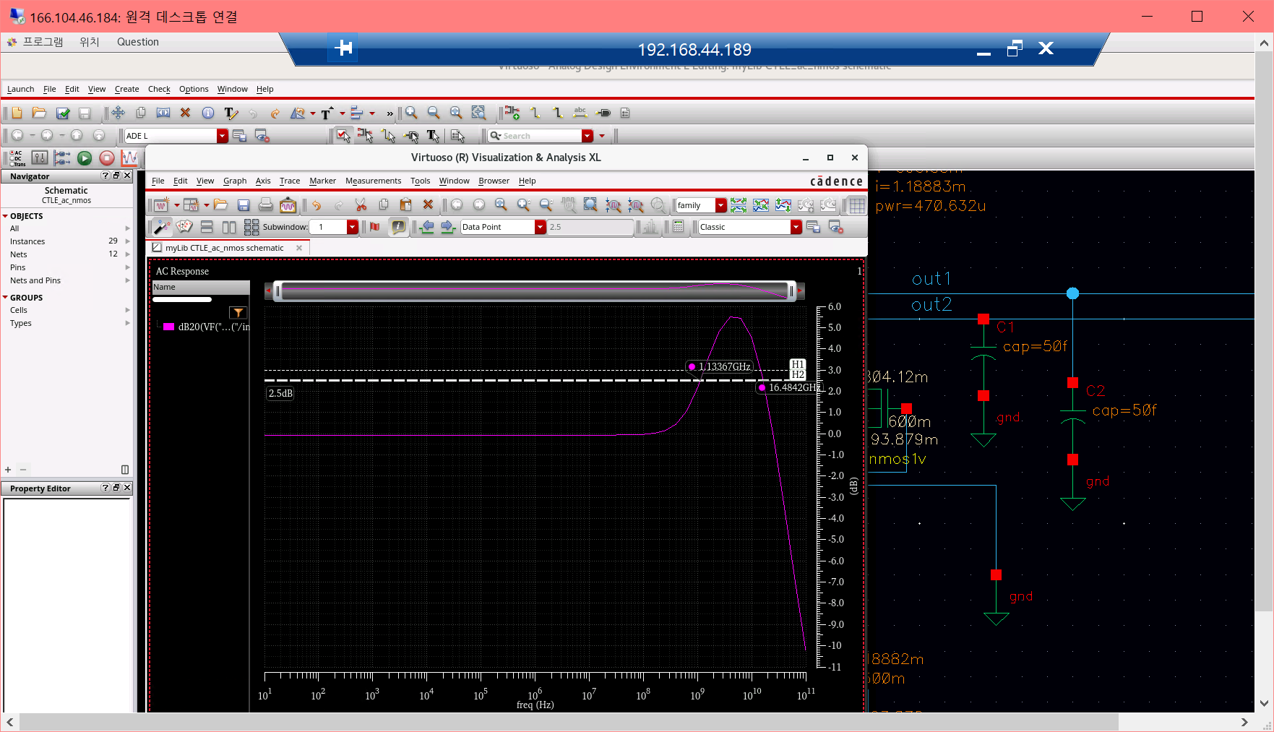

* AC gain=1.88 DC gain=0.993
* Zero frequency=1.13G, BW=16.48G
  1. **Fingers=25, 저항은 1/25배**

: diff pair-> finger width=0.62u, Fingers=25, Total width=15.5u

: current source nmos-> finger width=460n fingers=25 total width=11.5u

: Rs=680 ohms

: RL=400 ohms

: Cs=500f

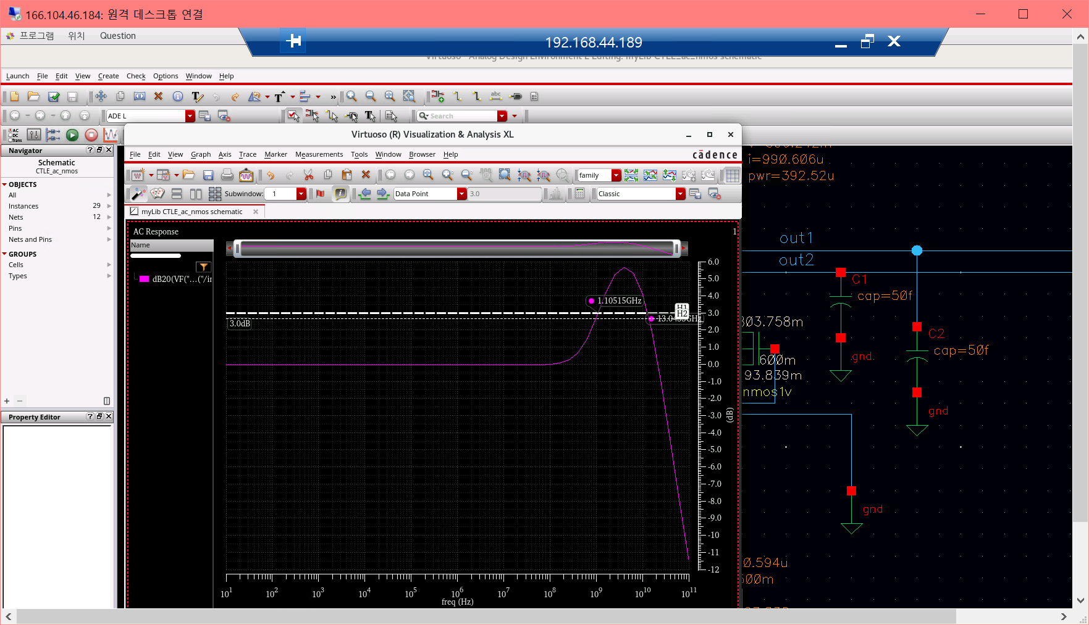

* AC gain=1.91 DC gain=0.993
* Zero frequency=1.105G, BW=13.96G
  1. **Fingers=27, 저항은 1/27배**

: diff pair-> finger width=0.62u, Fingers=27, Total width=16.74u

: current source nmos-> finger width=460n, fingers=27, total width=12.42u

: Rs=630 ohms

: RL=370 ohms

: Cs=500f

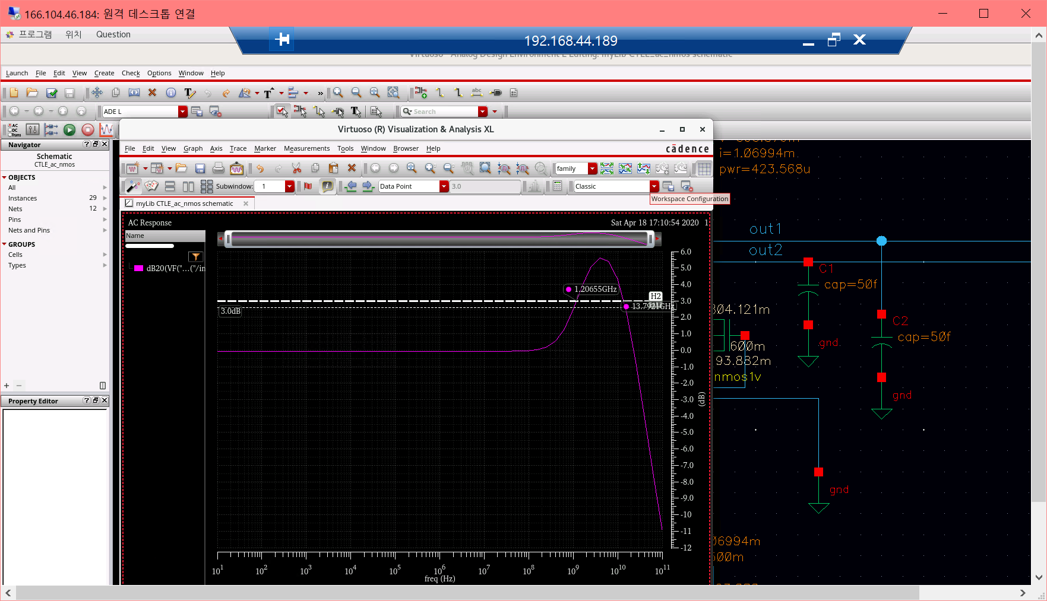

* AC gain=1.90 DC gain=0.993
* Zero frequency=1.21G, BW=14.91G

1. **(5.6)에서 AC gain을 낮게 나온 원인이 zero와 pole이 가깝기 때문이라고 분석**

**따라서 AC gain을 높이고, zero frequency를 낮추기 위하여 Cs를 600fF으로 늘림**

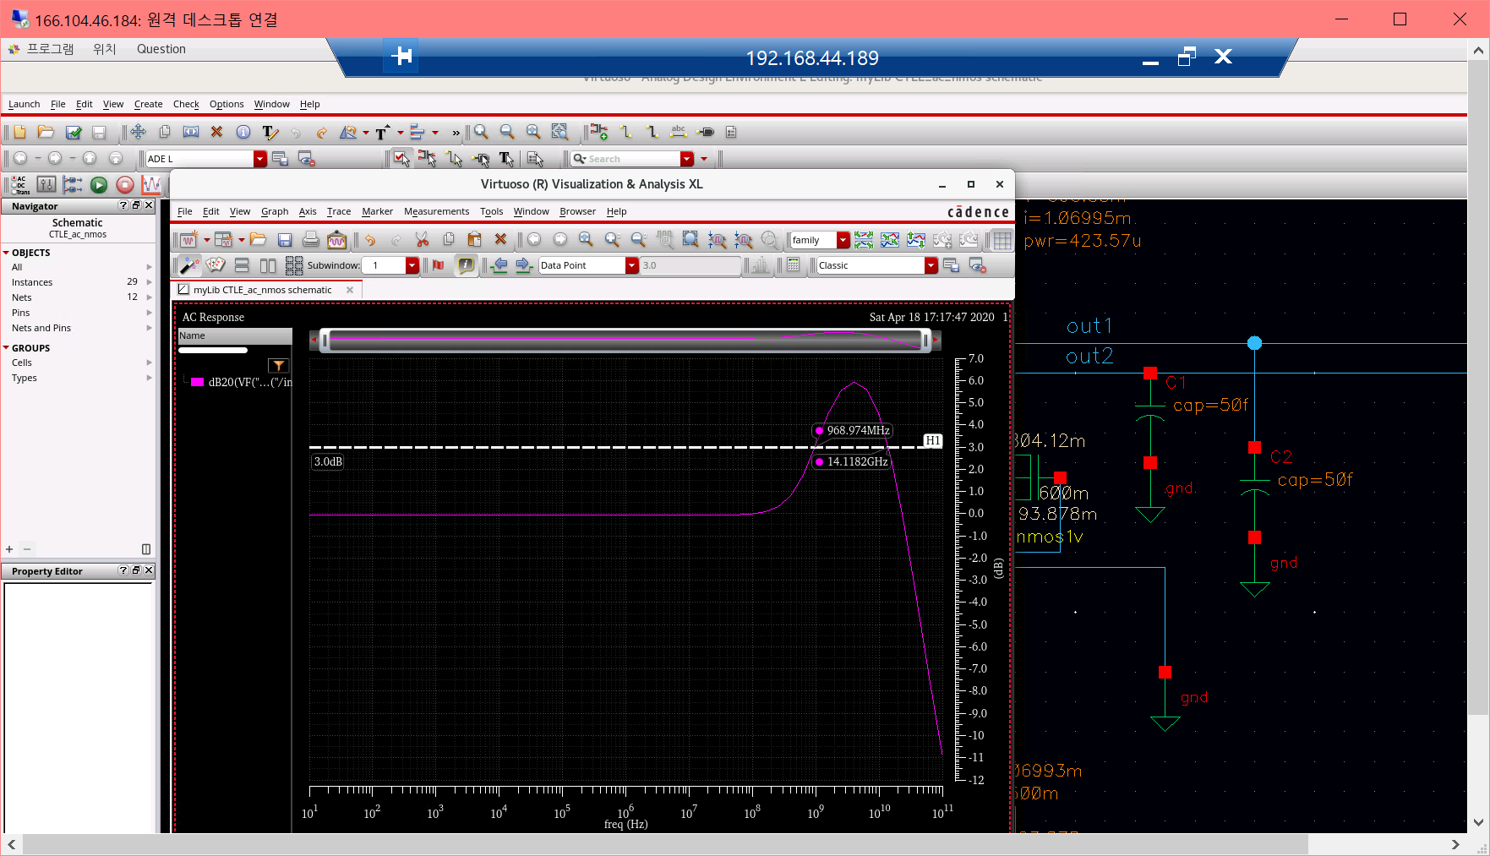

* AC gain=1.97 DC gain=0.993
* Zero frequency=969M, BW=14.3G

1. **DC-OP 시뮬레이션**

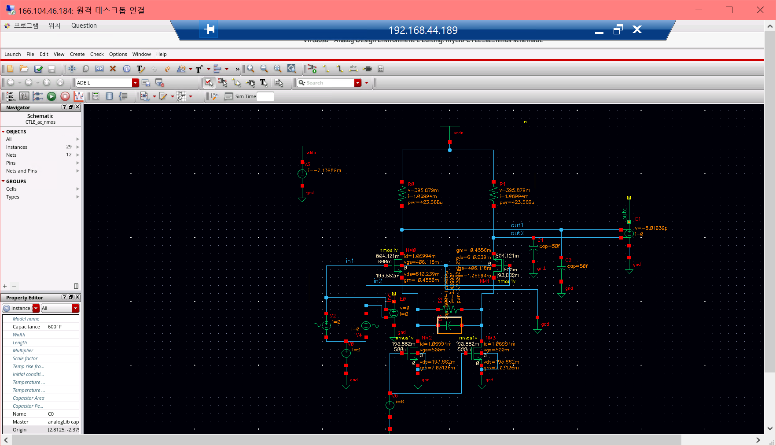

gm=10.456m, id=1.07m, gm/id=9.77

1. **DC 시뮬레이션(VTC)**

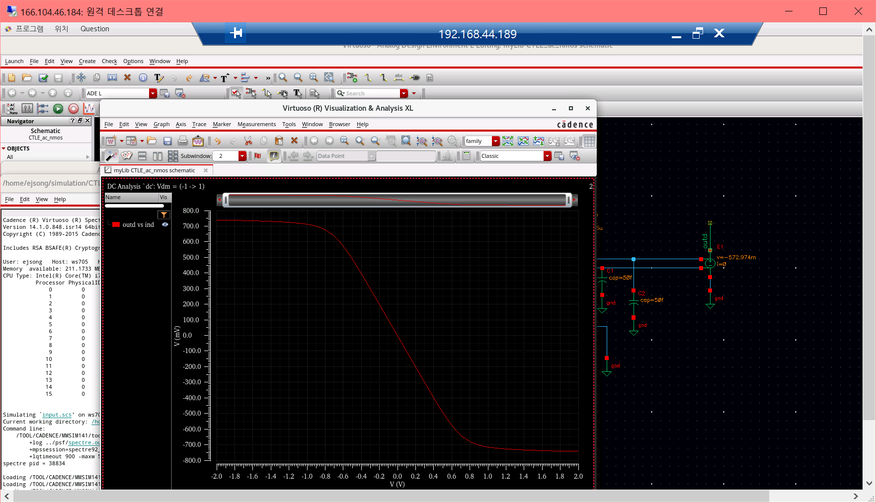

1. **AC 시뮬레이션(Frequency response)**

